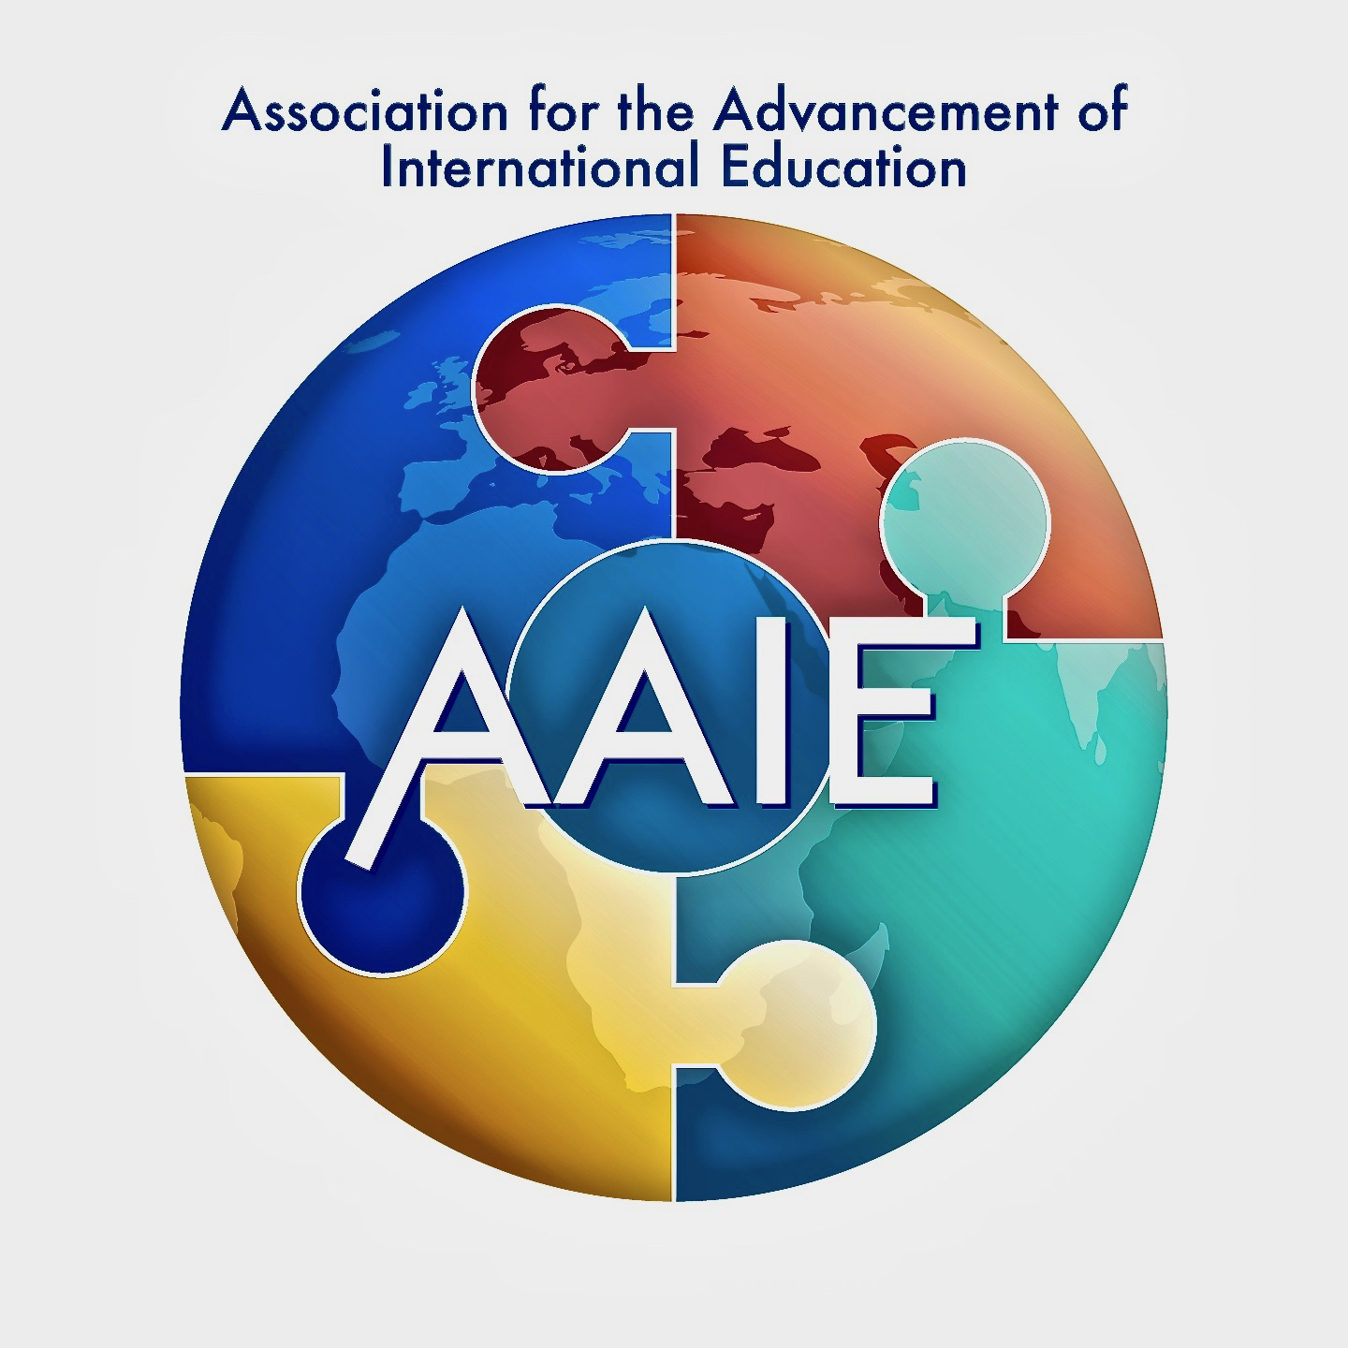
Association for the Advancement of International Education:
Call For Speaker/Presentation Proposals
New York City AAIE CONVERSATION, February 1-5, 2020

Theme: “Diverse on Purpose, Different By Design”

Note: Click on each field and complete. The field will expand. Review the definitions of the three types of presentation sessions below. Please submit a separate proposal for EACH type of session. Then save as a pdf file and send to Mark E. Ulfers, Executive Director at: Mark@AAIE.org RETURN TO Mark Ulfers and AAIE by SEPTEMBER 30, 2019

 | Professional Details
Name (First, Last)
Email Address
Mobile Phone
School/Institution/Company Name
Role/Job Assignment
Address
Years Working Overseas
 | Presentation Details
Title of Presentation Proposal
Theme(s)/Topic(s)/Concept(s)
Type of Presentation (choose one) | Check Box | - Full-Day Preconference:  ___one-day (Feb 2) ____two-days (Feb 1-2)
 | Check Box | - AAIE “HeadTalk” –an18-Minute Sharing of Powerful Ideas About the Future of International Education and Teaching and Learning, presented to full community of conference participants- THINK DIVERSITY.
 | Check Box | - Half-Day “Deep Dive” Interactive Session
 | Check Box | - Organizing a Panel Discussion:  “Unpacking the Truth-Addressing Key International School Leadership Issues”
 | Check Box | - Legacy Leaders Learning Series- From Boomers to Millennials to Gen-X’ers
Objectives of the Presentation
Description of Presentation
How Presentation Connects to CONVERSATION THEME and AAIE Mission?
How Presentation Supports International Schools and Students Becoming Future-Ready
Does Your Presentation Describe a School Success Story? (Explain)
Describe Your Intended Audience (Leadership roles and responsibilities)
What are the media/AV Needs?

Session Definitions:

- LEAD A PRECONFERENCE: Present individually or as a team, an all-day preconference and/or key learning for the FUTURE of our international schools. Your presentation is meant to support our AAIE leaders in taking on the very real challenges and complexities of international education and our preferred future.

- THE "HeadTalk" PRESENTATION: Similar to a Tedx Talk format– AAIE will sponsor our own "HeadTalk" sessions, an eighteen-minute talk about the future of teaching and learning that challenges our assumptions, understanding and thinking. We all must remain awake to new ideas. The future always remains, and AAIE "HeadTalks" are meant to poke us with a sharp stick and then challenge us to learn more.

- THE AAIE DEEP-DIVE "Solutions" PRESENTATION: A deep dive made up of two 60-minute, back-to-back sessions to define, explore and address leadership challenges, opportunities and possible solutions for international education leaders. Each session offers alternatives and solutions to complex leadership issues. As the facilitator, the responsibility is to clarify guiding questions around a THEME or CRITICAL ISSUE, curate resources, invite expert contributors, plan discussions (ex. panel discussions) that engage all participants, and then prepare a brief share-out session about possible solutions for the final large-group Closing General Session. Highly participatory sessions.

- ORGANIZING A PANEL DISCUSSION FOR THE MAIN STAGE: Take the initiative and help organize a full AAIE community panel discussion in the main AAIE conference hall/ballroom. Use the conference theme or focus on the future and key leadership attributes and dispositions and name your own panel members (think diversity– from age, gender and cultural backgrounds) and develop a key essential question you and your panel will attack in front of the entire AAIE CONVERSATION audience.

- LEGACY LEADERS LEARNING SERIES: We will select a group of international school leaders who span the generations to speak on the challenges within international school leadership– focusing on what is changing and how we must take Kurt Vonnegut’s sentiment, “To jump off a cliff and develop wings on the way down.” There is risk and danger in leadership and the change process and we must speak about it.

If you are willing to join a group of school leaders who will form this unique speaking and panel discussion, fill out the proposal form with your perspective on what is the most risky, daunting, and difficult leadership and change activity in your international school. Fill the form out as an individual, discussing within the proposal the most daunting leadership task and how you are leading your school toward a resolution and overall school improvement. Each person speaks for ten minutes then the entire AAIE community gathered in the ballroom sparks a town hall “Q and A” meeting.

- Make sure to fill out a separate proposal form for EACH presentation you wish to submit to the AAIE Advisory Council for review.

